Village of Decorative Painter’s

Fall Retreat 2026
“It’s a Colorful World”
When: Sept. 25,26,27, 2026
Where: Skyline Camp and Conference Center, 5650 Sandhill Rd., Almont, MI 48003
Time: Check-in Friday 3:00 pm through Sunday 4:00 pm (check out of room by 11:00)
Includes: 2 nights lodging, 5 meals, hayride and teaching fees
Cost: Members Non-Members
$220 $235
Register: now till…………Aug.8
Linens available for $15
A maximum of 25 pence may be used.
Once again, we will be having a raffle on Sunday morning to benefit Skyline.
PAINTING CHALLENGE: You’ll receive a fabric bird when you register to decorate and create a piece of art any way you would like.

Friday Night: Paint a Mandala Stone
This will be a paint on your own project.
Rocks 4” round, Paint and many ideas will be available. Cost $3

Saturday Classes
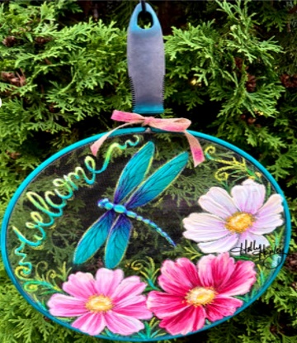
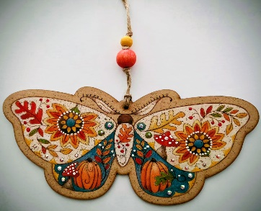
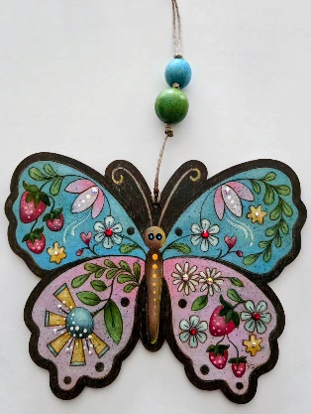
Sam Farah- Paint and Pencil both projects. Judy Ribitch- Screen/ Acrylic w/ Texture Paste
Erika Joanne – Bristol Butterfly & Fallberry Moth Holly Hanley- Cosmos & Dragonfly Paints will be provided a list of pencils will be sent to you.
Cost-$18 both kits Cost-$10
Sunday Classes

Marilyn Cunningham-Acylic on Wood/Metal Judy Ribitch- Acrylic on a Bisque Tile
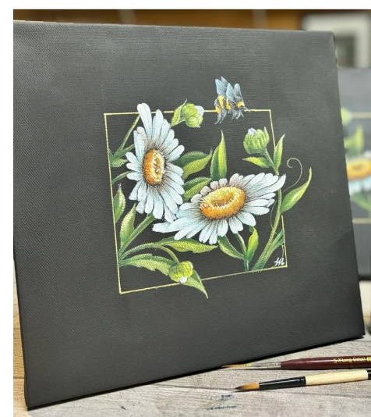

4x4x17” Cost- $19 8x8 Cost-$18
“It’s a Colorful World”
Sept. 25,26,27, 2026
Name__________________________________________________________________
Phone #_____________________________ Email_____________________________
Emergency Contact: Name___________________ Phone #__________________
Members $220 _________ Non-Member $235 _____________ Total _______
Friday Night Mandala Rock ($3) _________ extra surface______ Total ________
Please check the class you would like to take. You may order the pattern/kits of the other class if you wish.
Saturday Classes: choose one project
Bristol Butterfly +Fallberry Moth ($18) _____ extra kits ______ Total $________
Cosmos and Dragonfly Screen ($10) ______ extra kit _______ Total $_______
Sunday Classes: choose one project
Marilyn Cunningham Bird House ($19) _____ extra kit______ Total $_______
Ox Eye Daisies ($18) __________ extra kit_______ Total $________
Linens ($15) Total $________
Total $________________
A list of paints and supplies will be emailed to you by your teacher.
Please note any food allergies or special dietary needs. ______________________________________________________________________
Roommate Preference: _____________________________________________________
All rooms have 2 bunk beds sleeping 4 max except for the 4 corner rooms that have 3 bunk beds sleeping 6 max. We will be only using bottom bunks. You may want to bring a foam topper for your mattress.
Any questions call Paula Atkinson 248-798-5312 or paulawog43@aol.com
Make checks payable to: Village of Decorative Painters
Mail registration to: Kathy Fischer 8486 Warner Rd. Saline, Mi 48176 734-649-3262

