Village of Decorative Painters presents Holly Hanley
Saturday & Sunday, May 23 & 24, 2026

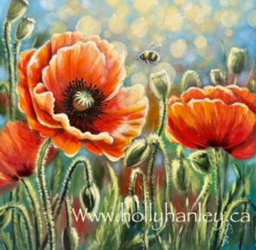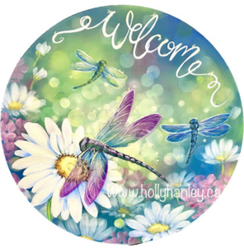
Poppies: Saturday, May 23 Dragonflies: Sunday, May 24

Time: 9:00 am – 4:00 pm (EST) Surface: You provide
On-Site: Livonia Senior Wellness Center Acrylic Paints: May be provided
15100 Hubbard
Livonia, MI 48154

Cost: Member $40 (no limit on pence); Non-Member $60
Deadline: May 8, 2026

Please remember that all fees are non-refundable and non-transferable.
Contact Diane Stiller (313) 720-1836 (leave a text or voicemail) or dianestiller@sbcglobal.net if you have questions.

Keep top portion for your records. Include bottom portion with your check.

Holly Hanley: Saturday & Sunday, May 23 & 24, 2026

Name _________________________________________________ Saturday, May 23, Poppies ________ $40 Member; $60 Non Member

Phone # _______________________________________________ Sunday, May 24, Dragonflies _______ $40 Member; $60 Non Member

Email ________________________________________ Total Enclosed ________

Make check payable to: Village of Decorative Painters
Mail to: c/o Diane Stiller, 674 W. Canfield St., Detroit, MI 48201

