Village of Decorative Painters presents Paulette DiGesare
Saturday & Sunday, June 27 & 28, 2026
Two Options: On-Site at the Livonia Senior Wellness Center or on ZOOM

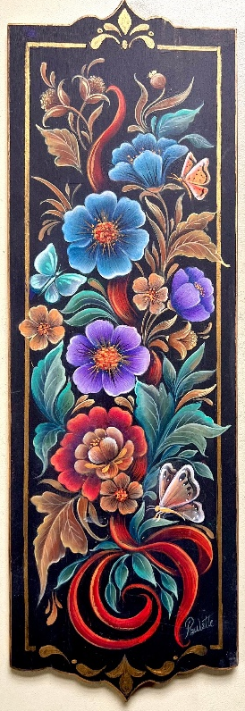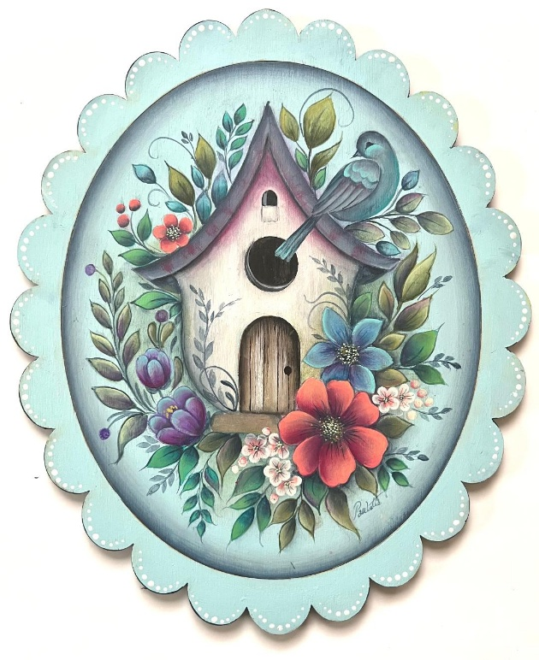
Ribbon Floral: Saturday, June 27 New Pattern Birdhouse: Sunday, June 28

Time: 9:00 am – 4:00 pm (EST) Surface: You provide
On-Site: Livonia Senior Wellness Center Acrylic Paints: May be provided, but not for Zoom classes
15100 Hubbard Class will be recorded
Livonia, MI 48154
ZOOM is an option

Cost: Member $40 (no limit on pence); Non-Member $60
Deadline: June 12, 2026

Please remember that all fees are non-refundable and non-transferable.
Contact Diane Stiller (313) 720-1836 (leave a text or voicemail) or dianestiller@sbcglobal.net if you have questions.

Keep top portion for your records. Include bottom portion with your check.

Paulette DiGesare: Saturday & Sunday, June 27 & 28, 2026

Name _________________________________________________ Saturday, June 27, Ribbon Floral ________ $40 Member; $60 Non Member

Phone # _______________________________________________ Sunday, June 28, Birdhouse _______ $40 Member; $60 Non Member

Email ________________________________________ Total Enclosed ________

Circle one: On-Site Class OR ZOOM class
Make check payable to: Village of Decorative Painters
Mail to: c/o Diane Stiller, 674 W. Canfield St., Detroit, MI 48201

