**Village of Decorative Painters presents Lydia Steeves**

**Color Pencil with Pan Pastel Background**

**Saturday & Sunday, September 20 & 21, 2025**

**ZOOM class only**

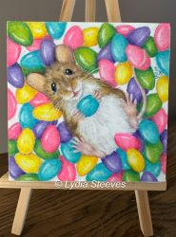

For Chipper Lovers: Saturday, Sept 20 Two 4” x 4” Critter Squares: Be Mine and Bobbing in Beans: Sunday, Sept 21

Time: 9:00 am – 4:00 pm (EST) Surface: You provide

Zoom class only Color Pencils & Pan Pastels: You provide

Cost: Member $30 (no limit on pence); Non-Member $40

Deadline: September 12, 2025

**Please remember that all fees are non-refundable and non-transferable.**

Contact Diane Stiller (313) 720-1836 (leave a text or voicemail) or [dianestiller@sbcglobal.net](mailto:dianestiller@sbcglobal.net) if you have questions.

Keep top portion for your records. Include bottom portion with your check.

**Lydia Steeves: Saturday & Sunday, September 20 & 21, 2025: ZOOM class only**

Name _________________________________________________ Saturday, Sept 20 Chipper Lovers ________ $30 Member; $40 Non Member

Phone # _______________________________________________ Sunday, Sept 21 Two Critter Squares $30 Member; $40 Non Member __________

Email ________________________________________ Total Enclosed ________

***Make check payable to: Village of Decorative Painters***

***Mail to: c/o Diane Stiller, 674 W. Canfield St., Detroit, MI 48201***