Village of Decorative Painters presents David Bailey
Watercolor
Saturday & Sunday, August 23 & 24, 2025

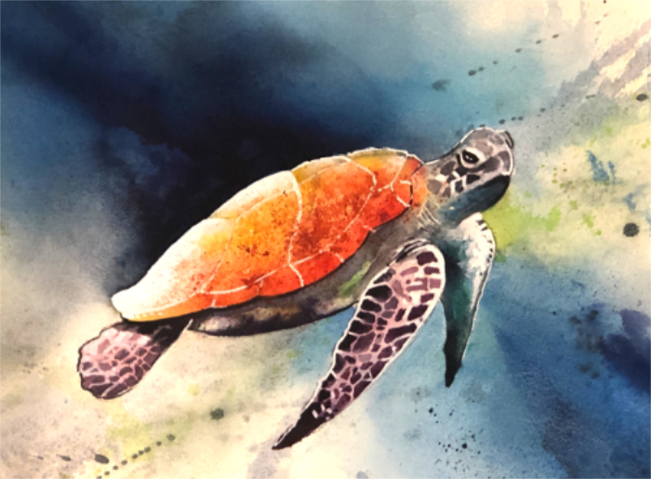
Saturday, August 23: Rainy Nights Sunday, August 24: Under the Sea

Time: 9:00 am – 4:00 pm (EST) Watercolor Paper: Provided
On-Site: Livonia Senior Center Watercolor Paints: Provided
15218 Farmington Rd.
Livonia, MI 48154

Cost: Member $55 (no limit on pence); Non-Member $75
Deadline: August 2, 2025

Please remember that all fees are non-refundable and non-transferable.
Contact Diane Stiller (313) 720-1836 (leave a text or voicemail) or dianestiller@sbcglobal.net if you have questions.

Keep top portion for your records. Include bottom portion with your check.

David Bailey: Saturday & Sunday, August 23 & 24, 2025:

Name _________________________________________________ Saturday, Aug 23: Rainy Nights ________ $55 Member; $75 Non Member

Phone # _______________________________________________ Sunday, Aug 24: Under the Sea _______ $55 Member; $75 Non Member

Email ________________________________________ Total Enclosed ________

Make check payable to: Village of Decorative Painters
Mail to: c/o Diane Stiller, 674 W. Canfield St., Detroit, MI 48201

