Village of Decorative Painters proudly presents
Judy Ribitch, White Asiatic Lilies
Via Zoom on Wednesday, November 6, 2024
Medium: Acrylic

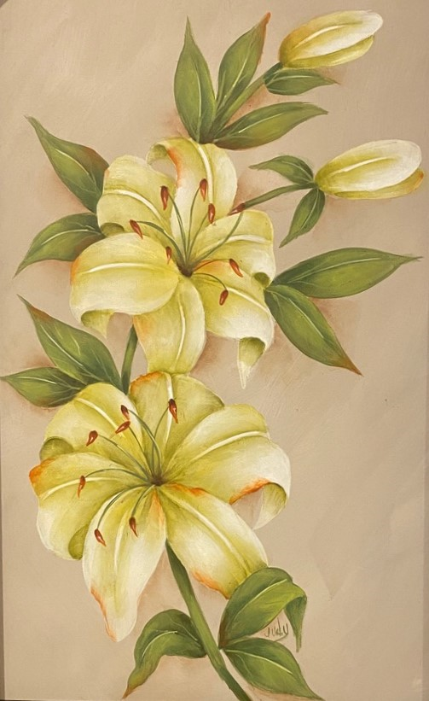

Time: 9:00 am – 4:00 pm Instructor provides pattern
Where: Zoom Student provides surface, paints, and usual painting supplies

Cost: Member $30 ($22 limit on pence); Non-Member $40
Deadline: October 23, 2024

Please remember that all fees are non-refundable and non-transferable.
Contact Diane Stiller (313) 720-1836 or dianestiller@sbcglobal.net if you have questions.

Judy Ribitch, White Asiatic Lilies, Via Zoom on Wednesday, November 6, 2024

Name _________________________________________________ Total Enclosed ________ $30 Member; $40 Non Member
Phone # _______________________________________________
Email ________________________________________

Make check payable to: Village of Decorative Painters
Mail to: c/o Diane Stiller, 674 W. Canfield St., Detroit, MI 48201

