Village of Decorative Painters presents New Patterns by Paulette DiGesare
Saturday & Sunday, June 21 & 22, 2025
Two Options: On-Site at the Livonia Senior Center or on ZOOM

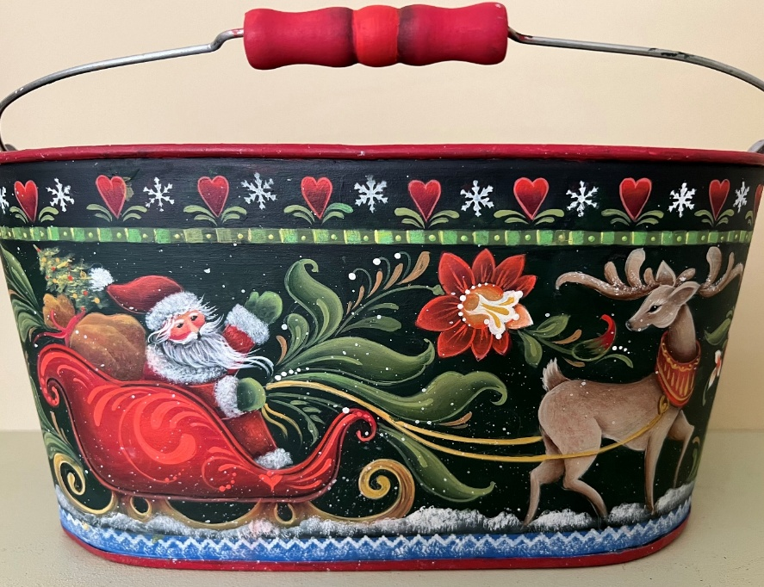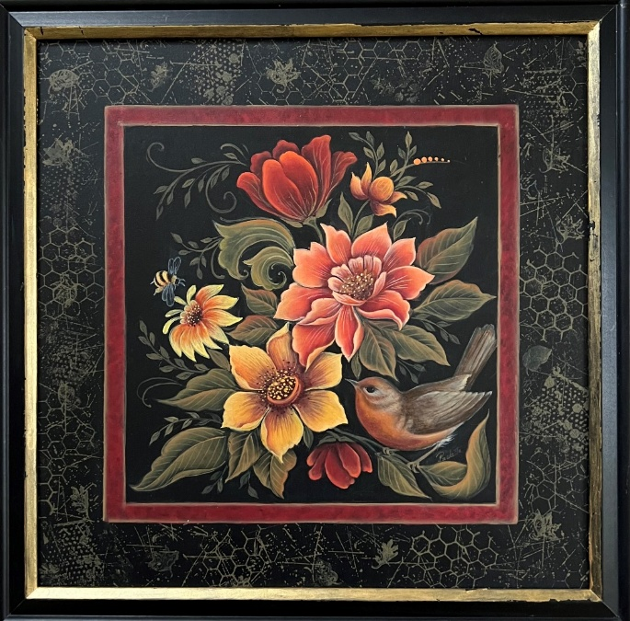
Santa Sleigh: Saturday, June 21 Flowers & Bird: Sunday, June 22
Surface: Oval metal bucket from Hobby Lobby SKU 1607712 Surface: 12” square, wood or MDF in a
Painted area is 14” long x 5-1/4” high; allow extra room all around 12” ready made frame from Michaels

Time: 9:00 am – 4:00 pm (EST) Surface: You provide
On-Site: Livonia Senior Center Acrylic Paints: May be provided, but not for Zoom classes
15218 Farmington Rd.
Livonia, MI 48154
ZOOM is an option

Cost: Member $40 (no limit on pence); Non-Member $50
Deadline: June 7, 2025

Please remember that all fees are non-refundable and non-transferable.
Contact Diane Stiller (313) 720-1836 (leave a text or voicemail) or dianestiller@sbcglobal.net if you have questions.

Keep top portion for your records. Include bottom portion with your check.

Paulette DiGesare: Saturday & Sunday, June 21 & 22, 2025

Name _________________________________________________ Saturday, June 21, Santa Sleigh ________ $40 Member; $50 Non Member

Phone # _______________________________________________ Sunday, June 22, Flowers & Bird _______ $40 Member; $50 Non Member

Email ________________________________________ Total Enclosed ________

Circle one: On-Site Class OR ZOOM class
Make check payable to: Village of Decorative Painters
Mail to: c/o Diane Stiller, 674 W. Canfield St., Detroit, MI 48201

